Undergraduate Research Opportunity

Overview
It has recently been recognized that skeletal muscle acts as an endocrine organ during physical activity, secreting various proteins or “myokines” that have widespread effects throughout the body. These myokines are thought to potentiate the beneficial effects of physical activity including inflammation relief, muscle hypertrophy and fat loss. Research demonstrates that energetic stress within the muscle induces the release of these myokines. In turn, energetic stress is determined by two variables, the energetic resources of the body before exercise and the energetic demand of the activity. In sum, we have a pretty good idea of how the body responds to exercise when it is performed in a western, energy-rich environment. However, from an evolutionary perspective, the way that we exercise today is substantially different than the physical activity our ancestors engaged in.
Physical activity (the non-structured form of exercise) was crucial to our survival during our evolutionary history. Hunter-gatherers, our closest analog to our ancestral way of life, show us that high levels of moderate physical activity are common in our species. In addition, the energetic context in which these individuals perform physical activity is very different from the conditions under which many of us exercise today. Given that myokine release is tied to energetic availability and exercise duration/intensity, we aim to perform a meta-analysis to answer the following questions:

- How does energy storage (BMI/%body fat) impact myokine release during physical activity?
- How does underlying metabolic disease affect myokine release during exercise?
- What is the dose response relationship between exercise duration and myokine release?

Research assistant description
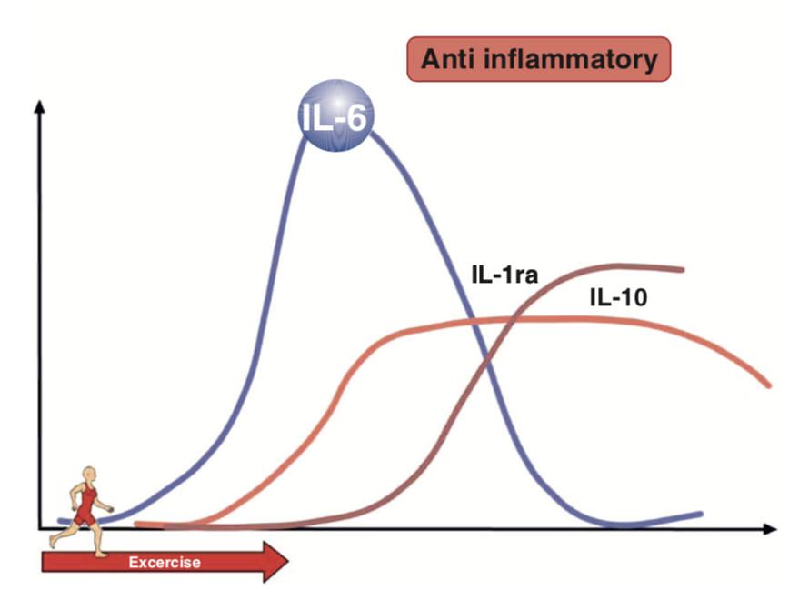
In this position you will work alongside a graduate student mentor and assist in research by:

-Screening paper abstracts for interesting papers
-Mining these papers for myokine data
-Perform statistical tests in R to answer questions stated above

While there are no hard and fast requirements for research assistants, it is extremely helpful if you have taken Evolutionary Human Physiology and Anatomy (LS2).

Learning Objectives
While performing this experiment, you will learn how to perform the following skills:
-Performing a meta-analysis
-Statistical Tests in JMP Pro/RStudio

If you are interested assisting in research, or want more information, contact Timothy Kistner at tkistner@g.harvard.edu.

